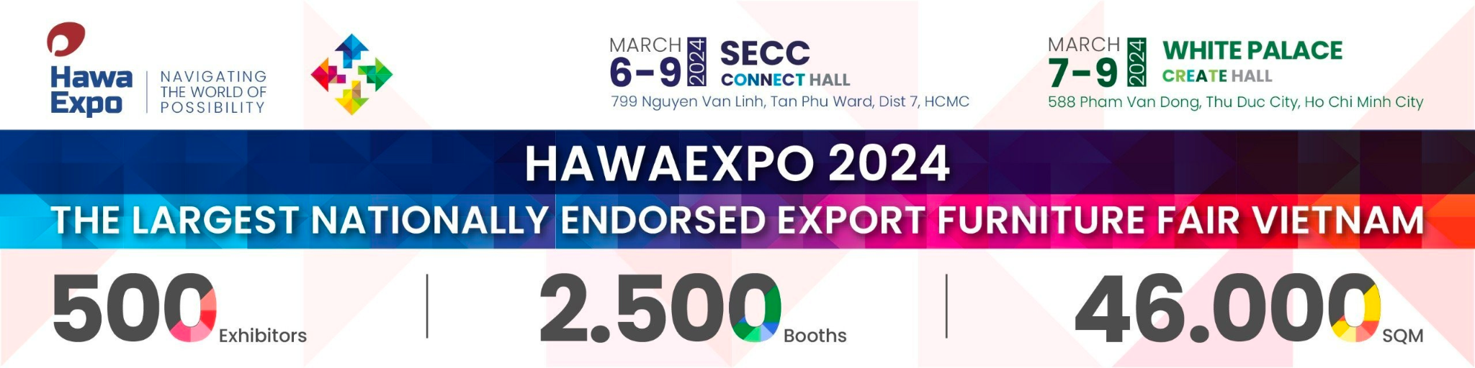
HAWAEXPO 2024 - EVENT FACT SHEET

Exhibition name | 𝐇𝐀𝐖𝐀𝐄𝐗𝐏𝐎 𝟐𝟎𝟐𝟒 – 𝐓𝐇𝐄 𝐋𝐀𝐑𝐆𝐄𝐒𝐓 𝐍𝐀𝐓𝐈𝐎𝐍𝐀𝐋𝐋𝐘 𝐄𝐍𝐃𝐎𝐑𝐒𝐄𝐃 𝐄𝐗𝐏𝐎𝐑𝐓 𝐅𝐔𝐑𝐍𝐈𝐓𝐔𝐑𝐄 𝐅𝐀𝐈𝐑 𝐈𝐍 𝐕𝐈𝐄𝐓𝐍𝐀𝐌  (https://www.hawaexpo.com)
Time | 9:00 - 17:00  6 - 9/3/2024
Venue | - 𝐂𝐎𝐍𝐍𝐄𝐂𝐓 𝐇𝐀𝐋𝐋 - 𝐌𝐚𝐫𝐜𝐡 𝟔-𝟗, 𝟐𝟎𝟐𝟒 - SECC - 799 Nguyen Van Linh Street, Tan Phu Ward, Dist. 7, HCMC  - 𝐂𝐑𝐄𝐀𝐓𝐄 𝐇𝐀𝐋𝐋 - 𝐌𝐚𝐫𝐜𝐡 𝟕-𝟗, 𝟐𝟎𝟐𝟒 - White Palace - 588 Pham Van Dong Street, Thu Duc City, HCMC
Organizer | - Organized by VIFOREST FAIR company, consisting of five associations: Viforest, HAWA, BIFA, DOWA, and FPA Binh Dinh  - Operated directly by the Handicraft and Wood Industry Association in Ho Chi Minh City – HAWA.
About event | Why HawaExpo 2024?  Truth-worthy organizer  Under the patronage of the Ministry of Agriculture and Rural Development, the Ministry of Industry and Trade, and the professional coordination of the Ho Chi Minh City Department of Industry and Trade, led by the top 5 national Wood & Furniture associations, HawaExpo is the largest export furniture fair and most influential international business networking platform that represents Vietnam in the ASEAN Furniture Fair Chain annually by March.  Beyond its role, HawaExpo 2024 is dedicated to the striving of organizers to optimize the authentic value for all participants. strengthen the made-in-Vietnam furniture trademark globally, execute the market expansion sustainably and constantly create many favorable conditions to optimize the business effectiveness for all participants.  >> The largest international networking platform to achieve authentic value targeted opportunity in Vietnam - a rising global furniture hub  - With 500 quality exhibitors bringing many hidden cards to the stage and a vast exhibition area of 46.000 sqm in all leading exhibition and convention centers, HawaExpo 2024 is undoubtedly a worth-waiting furniture exhibition for buyers around the globe.  - This is certainly the best business platform for buyers to establish a strong foothold in this rising market or to look for cooperation. HawaExpo 2024, as Vietnam’s representative at the ASEAN Furniture Fair 2024, will triple its scale in terms of exhibitors, products, and activities.  >> New exhibitors. New category. New opportunities  - Golden chance to catch up with the industry’s latest trends, shorten their evaluation time by viewing the well-rounded supply chain system, directly accessing crucial distribution partners, or interacting with other logistics, licensing solutions, materials & hardware companies.  - Different from other international fairs, HawaExpo strongly focuses on showcasing locally qualified enterprises and new profiles. Nearly 80% of around 500 exhibitors are made-in-Vietnam, and more than 80% are manufacturers  >> The most supportive international business platform  - Free shutter bus  -- Over 100 bus trips will be available daily during convenient hours.  - A dedicated team of professional guides will be at your service.  - 05 bus routes are arranged for easy transportation  - 20% discount on top accomodation  - Visa support  - Factory Visit  - B2B Matching  - Virtual Online Exhibition and hi-tech HawaExpo Application
Key figures | - 500+ exhibitors; nearly 80% made-in-Vietnam origin; > 80% manufacturers serving all-sized orders  - 2.500 booths, in area of 46.000 square meters  - 25.000 buyers & visitors  - 100+ countries & regions  - 20+ key events  - 75k + products
New fact
Key exhibiting categories | - Kitchen & Dining Room Furniture: > 250 brands  - Living room Furniture: > 200 brands  - Bedroom Furniture: >170 brands  - Upholstery leather: > 80 brands  - Home accessories & interiors decor: > 200 brands  - Gift & Handicraft: 120 brands  - Outdoor & garden furnitures: > 140 brands  - (new) Hospitalities & project furniture: > 180 brands
Major buyer countries | - United State  - Australia  - United Arab Emirates | - United Kingdom  - France  - Italy | - India  - Korea  - Japan  - Malaysia
Featured shows & events | More than 20 key events and more pop-up events hosted by exhibitor  Key events as below:  Wed, 6th Mar 2024  - 9:00 - 10:00: HawaExpo 2024 - Connect Hall Opening Ceremony  - 13:00 - 16:30: Vietnam Business Industry Forum  Location: 𝐂onnect Hall - SECC  - 18:00 - 21:00: Gala Dinner x Create Hall Opening Ceremony  Location:: Create Hall - White Palace  Thu, 7th Mar 2024  - 14:00 - 16:00: Seminar - GREEN FINANCE FOR WOOD & FURNITURE INDUSTRY  Location: 𝐂onnect Hall - SECC  - 9:30 - 11:00: Design Talk 01 Dual skill to be global furniture designer  - 14:00 - 16:00: Workshop THE ESSENCE OF VIETNAMESE HANDWOVEN CRAFTMANSHIP  Location:: Create Hall - White Palace  Fr, 8th Mar 2024  - 9:30 - 11:00: Seminar CROSS-BORDER E-COMMERCE - GLOBAL GROWTH OPPORTUNITY FOR VIETNAM FURNITURE INDUSTRY  - 13:00 - 16:30: CONSULTING SESSION: THE A-Z OF STARTING AN E-COMMERCE BUSINESS  - 14:10 - 16:30: UNDERSTANDING EU DEFORESTATION REGULATION AND AMERICAN HARDWOODS WITH AHEC  Location: 𝐂onnect Hall - SECC  - 9:30 - 10:30: Design Talk 02 From Paper to Reality: A Wise Guideline to turn design into products  - 14:00 - 16:00: Workshop THE ESSENCE OF VIETNAMESE HANDWOVEN CRAFTMANSHIP  Location:: Create Hall - White Palace

About the event organizer:
MEDIA CONTACT:
M

