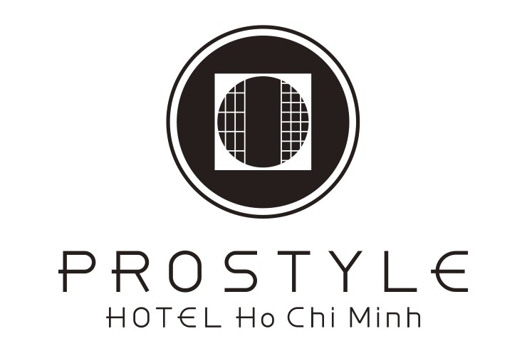

REGISTRATION CARD
CONFIRM NO: | FOLIO NO:

GUEST INFORMATION
Guest Name: | Birth Date:
Company: | Email:
Phone: | Address:
Fax: | Nationality:
Visa: | Visa Expiry:
Passport:
Notice:

RESERVATION DETAILS
Arrival Date: | Departure Date:
Room Type: | Room No:
Adult/Child: | TA/Company:
Nights: | Room Charge:

PAYMENT METHOD
CASH VND | CASH USD | Credit - Amex Card
Bank Transfer | Credit -VCB Master | Credit - ATM Card

TERM & CONDITION
1. Check-in time is at 14:00 – Check out time is at 12:00
2. Smoking is not allowed in all the guest rooms.
3. Cooking or any form of meal preparation is not allowed inside the room.
4. Adults guests are responsible to supervise their children on the balcony, swimming pool, and in any dangerous area.
5. Money, jewelry, and other valuable items should be kept by Guestself.
6. Guest also agrees to be personally liable if the indicated person, firm, or corporation fails to pay any of the charges incurred and Guest shall make an immediate payment direct to the hotel.
7. We will not be responsible in case of any loss, damage, or injury suffered at the property.

Guest's Signature | Reception's Signature

Prostyle Hotel Ho Chi Minh
Address: 26 Thi Sach St, Ben Nghe Ward, Dist. 1, Ho Chi Minh city
Phone: (02) 83 8272 838 - Email: info@prostylehotel-hcm.com - Web: (02) 83 8272 838

